**Mindanao State University**

**Maigo School of Arts and Trades**

**Maigo, Lanao del Norte**

**COMLAB**

**MONITORING SYSTEM**

**(Computer Laboratory Monitoring System)**

**-Group 4-**

**Members:**

**Antiola, Rica Angelou M.**

**Aves, Cydrick M.**

**Bendanillo, Jenneferlyn B.**

1. **Rationale**

In the rapidly evolving landscape of educational technology, the need for effective management and monitoring of computer laboratories within academic institutions has become increasingly crucial. The integration of a Computer Laboratory Monitoring System seeks to address the challenges associated with resource management, security, and accountability in these dynamic environments. This system caters to the specific roles of administrators and Comlab faculty members, streamlining their tasks and enhancing the overall efficiency of computer lab operations.

The Computer Laboratory Monitoring System is design to facilitate efficient management and monitoring of computer labs within an educational institution. This system will primarily serve administrators and Comlab faculty members, providing them with tools to oversee lab activities, manage users, devices, and generate relevant reports.

The rationale behind implementing a Computer Laboratory Monitoring System lies in the recognition of the unique demands placed on administrators and faculty in managing a computer lab. As technology continues to play a pivotal role in education, the need for a centralized system that facilitates user and device management, real-time monitoring, and comprehensive reporting has become paramount. This system aims to provide a structured and secure environment, ensuring optimal utilization of resources, enhancing security measures, and fostering a conducive learning and working atmosphere for both administrators and faculty members.

1. **Problem Statement**

* **Inefficient Resource Management** - Without a centralized system, administrators struggle to keep track of users, devices, and their activities in the computer lab. This can result in inefficiencies, such as underutilized resources or conflicts over device availability.
* **Security Concerns** - The absence of a proper monitoring system can lead to security vulnerabilities. Unauthorized access to the lab, untracked device assignments, and inadequate control over user activities pose significant risks.
* **Manual Reporting and Documentation** - Administrators and instructors may rely on manual methods for maintaining user lists, device inventories, and activity reports. This manual approach is time-consuming, prone to errors, and lacks real-time insights.
* **Limited User Accountability** - Instructors face challenges in managing device assignments and tracking user activities effectively. This lack of accountability can lead to confusion and hinder the overall learning and working environment.

1. **Project Objectives**

* **Efficient Resource Management** - The system allows administrators to add, update, and view user lists, as well as add, update, and remove devices from the inventory. This ensures a centralized and up-to-date repository of lab resources.
* **Enhanced Security** - Access control features, including user authentication and authorization, are implemented. Administrators can monitor and control lab access, track device assignments, and receive alerts for unauthorized activities, thus improving overall security.
* **Automated Reporting and Documentation** - The system automates the generation of reports for both administrators and instructors. This includes user lists, device lists, and activity reports with date and time stamps. This reduces manual effort, minimizes errors, and ensures real-time insights.
* **Improved User Accountability** - Instructors have the necessary functionalities to manage device assignments, track borrow and return activities, and view reports relevant to their responsibilities. This enhances user accountability and facilitates a smoother learning and working experience.
* **User-Friendly Printing Options** - Both administrators and instructors can easily print reports for reference or documentation. The system allows for the printing of user lists, device lists, and relevant reports, promoting accessibility and ease of use.

1. **Scope of the Project**

**Inclusions:**

* **Administrator Functionality:**
* User Management
* Add, edit, remove, and view users.
* Assign roles.
* Device Management
* Add, update, and view devices.
* Edit or remove devices from the inventory.
* Borrow Device Management
* View the list of borrowed devices.
* Edit availability status.
* Assign or remove devices to/from faculty and users.
* Return Device Management
* View the list of returned devices.
* Edit device status, faculty, and user information.
* Reporting
* View reports on user and device lists.
* Print all list of user and all devices information
* Print reports including date and time.
* **Faculty Members Functionality**
* Device Management
* Add, update, and view devices.
* Edit or remove devices from the inventory.
* Borrow Device Management
* View the list of borrowed devices.
* Edit availability status.
* Assign or remove devices to/from faculty and users.
* Return Device Management
* View the list of returned devices.
* Edit device status, faculty, and user information.
* Reporting
* View reports on the device list.
* Print all devices information
* Print reports including date and time.

**Exclusions:**

* Direct control over user information for instructors.
* Advanced user management functions for instructors.

1. **Context Diagram**

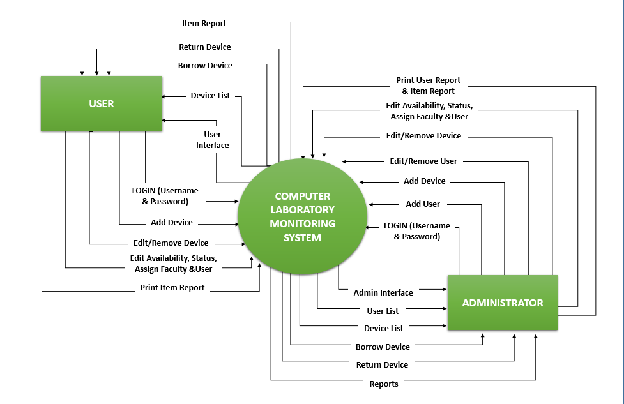

1. **Entity Relationship Diagram (ERD)**

